Admissions Appeals by LA

This document walks through five steps used to create a clean version of the Admissions Appeals by LA Dataset that you can use as data for your data journalism portfolio. The aim was to create a file that could be analysed and visualised with a minimum of issues. In this case, that meant breaking down the data into usable chunks.

The data for this dataset was generated using the Government’s education data table explorer - https://explore-education-statistics.service.gov.uk/data-tables

In the case of this data, there were two steps.

Step 1: Create an Excel version 2
Why? 2
Step 2: Filter the contents into useful buckets 2
Why? 3

Step 1: Create an Excel version

- Open the AdmissionsAppeals_LA.csv file in EXCEL
- Select Edit > Save As
- Make sure the File Format is XLSX
- Change the file name to AdmissionsAppeals_LA_CLEAN
- Save the file

Why?
The data is provided as a CSV (Comma Separated Values) file. It’s one of the most common tools in a data journalist’s kit. At its simplest, it stores structured data in a text file.

Each line in a CSV file represents a row, and each piece of information (a cell) is separated by a comma. The first line is usually header information. For example, a row of data would look like this in its raw form:

Date,Region,Wait_Time
2026-02-22,North West,18

While Excel files are great for personal use, data journalists often prefer CSVs for several professional reasons:

- Universal Compatibility: You can open a CSV in any program—Excel, Google Sheets, Notepad, or professional coding languages like Python and R. It doesn't matter if your colleague uses a Mac and you use a PC; the file will always look the same.
- Smaller File Size: Because CSVs are just plain text without fancy formatting, or any of the other bells and whistles, the files are much "lighter." This makes them easier to download from government portals and faster to process when you have millions of rows of data.
- Data Integrity: Excel sometimes tries to be "helpful" by automatically changing data (like changing a date format). A CSV stores the data exactly as it is, which reduces the risk of accidental errors in the data.
- Future-Proofing: File formats like .xlsx can become outdated as software versions change. Plain text files are a basic, universal format.

The "Golden Rule"
When you get a data set, keep the original CSV as your "source of truth." If you want to clean the data or add formulas in Excel, save a new copy as an .xlsx file. This ensures that if you make a mistake in your calculations, you can always go back to the original, untouched text file to verify your facts.

Step 2: Filter the contents into useful buckets
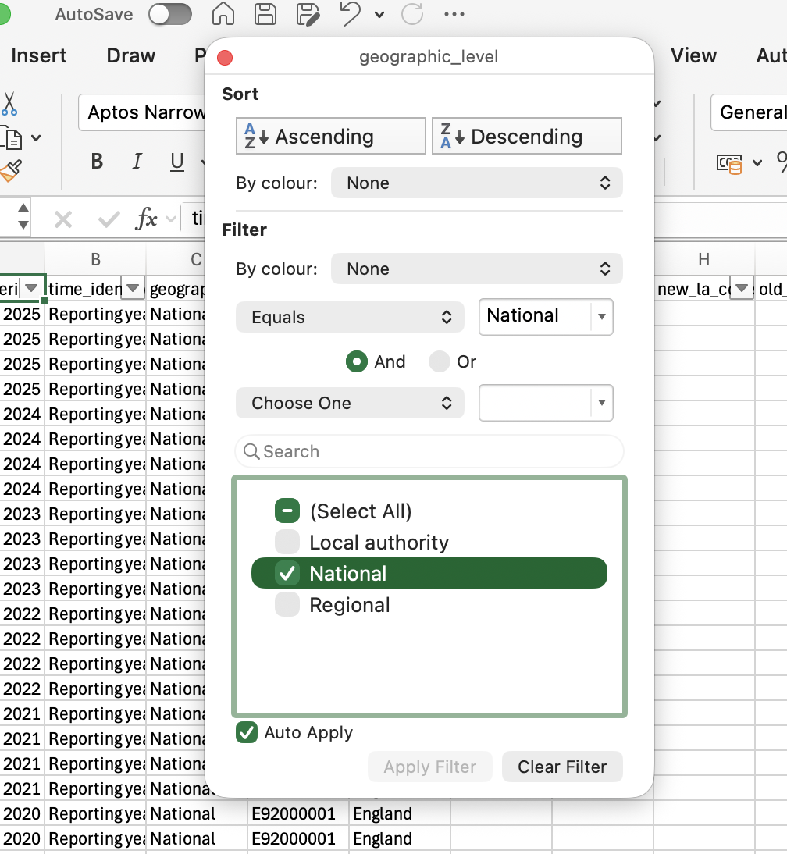
- Make sure you’re working with AdmissionsAppeals_LA_CLEAN.xlsx
- Click in any cell
- Press CTRL+ SHIFT + L to toggle the column filters on.
- Select the filter on the geography column
- Select National
- Select CTRL+ A or CMND+A to select all the filtered cells
- Select Edit > Copy
- Click the + next to the existing sheet tab
- Click the first cell in the new sheet and select Edit > Paste
- Rename the sheet National
- Press CTRL+ SHIFT + L to toggle the column filters on this new sheet.
- Repeat this to create new sheets for data filtered by Regional and Local Authority.

Why?
The data is split into different administrative geographies - National, Regional, and Local Authority. Keeping them mixed in this way could be a problem; we could end up combining and double-counting figures. Better to split them out and give us clear sub-sets of the data we can work with.

- National gives us a year-by-year for the whole of England.
- Regional allows us to compare regions of England. These are geographical regions used by ONS
- Local Authority is a generic term used by the ONS and others for councils

You’ll notice that each geographical element also has a code attached eg.
- E92000001 England,
- E12000002 North West and
- E08000003 Manchester.

Because they are standard across government, they can be a useful key to matching data across data sets.

Have a look at the link below to see how the codes link data - https://www.ons.gov.uk/explore-local-statistics/areas/E08000003-manchester/indicators

